

**Break Out Rooms**

**for Online Classes**

**with Pink Umbrella Theater**

Pink Umbrella Theater Company

Milwaukee, WI 53202

414-507-3511 (cell)

[katie@pinkumbrellatheater.org](mailto:katie@pinkumbrellatheater.org)

Created: July 2020

Updated: July 2020

I am participating in an Online Class with Pink Umbrella Theater Company!

This class is held online through a website called ZOOM.



I access the class on my phone, tablet or computer.

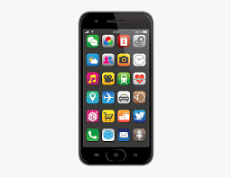 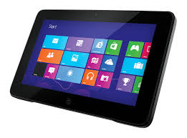 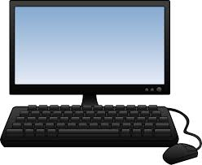

During class my teacher might send me to a Breakout Room.

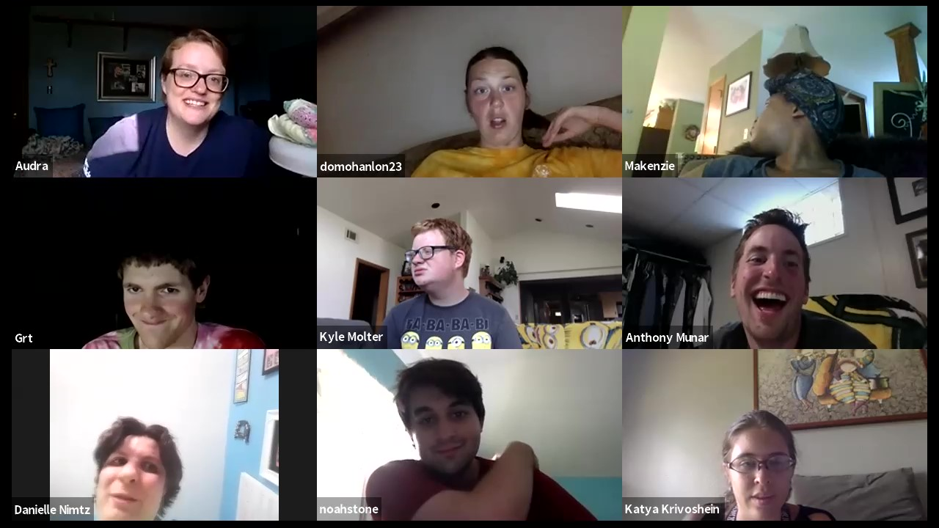

I will join the Breakout Room to do the work the teacher has asked me to do.

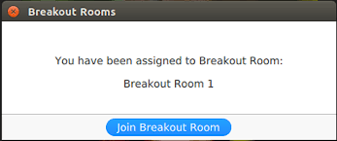

I will be in the Breakout Room with classmates and/or one of my teachers. The Breakout Room is part of our classroom and can help me work on an activity that is part of our class.

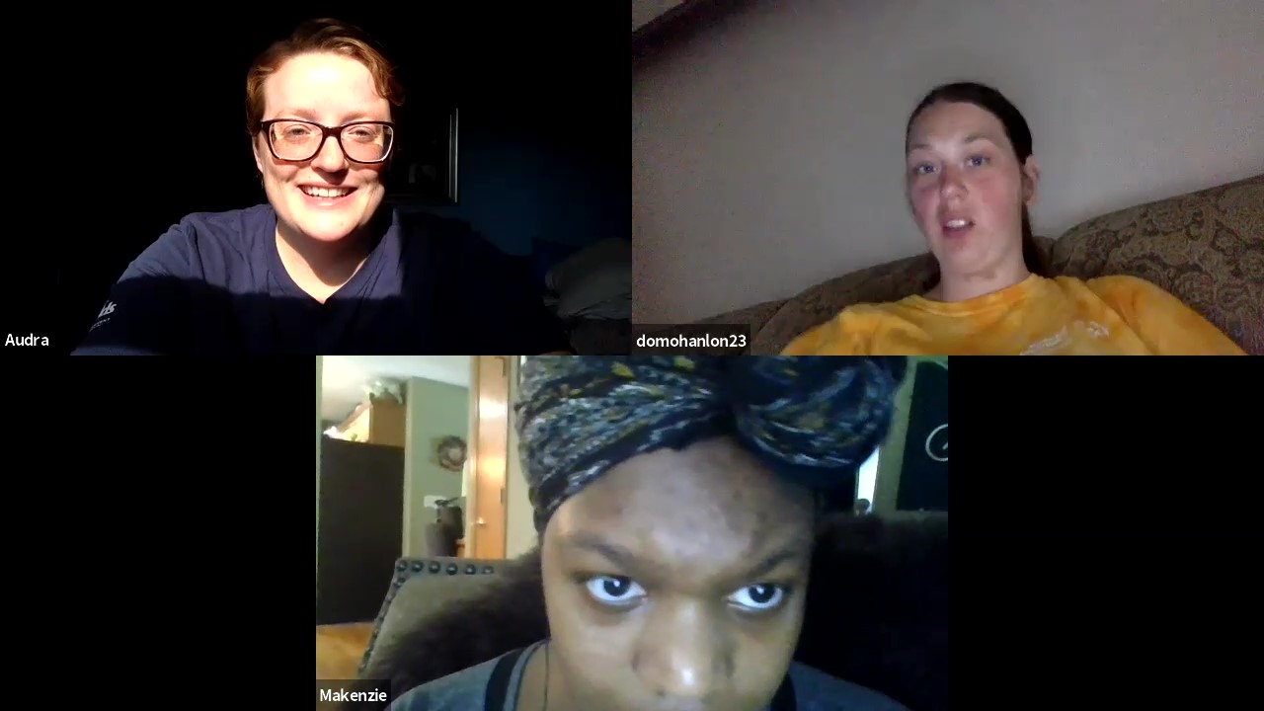

I like to do work in the Breakout Room so that I can work on my acting and improvisational skills.

My teacher might send us a message in the Breakout Room. A box will pop up with their message.

When it is time to leave, my teacher will let us know.

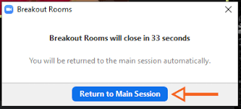

I will return to the main session, which is another name for my class, and resume class with everyone!

