Using ZOOM
for Online Classes
with Pink Umbrella Theater

Pink Umbrella Theater Company
Milwaukee, WI 53202
414-507-3511 (cell)
katie@pinkumbrellatheater.org
Created: March 2020
Updated: May 2020

I am going to participate in an Online Class with Pink Umbrella Theater Company!

This class will be held online through a website called ZOOM.

I can access the class on my phone, tablet or computer.

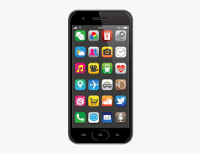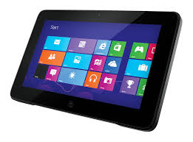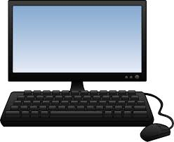

I will need internet access and a strong wifi connection.

My device should have a full battery before I join class.

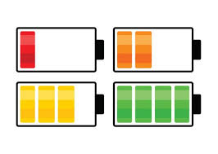

I need to be able to move during class, so if I am using a phone or a tablet, I should prop it up to make sure my hands are free and that people can see me.

Other people in my house (parent, caregiver, aide, sibling, etc.) might be in the room with me while I take class. If I need help, I can ask the people who are in the room with me. I can ask my teacher for help, too!

This is how I can log in for an online class.

I will receive an email with a link for the meeting. If I can’t find the link I can email Katie and she will resend it.

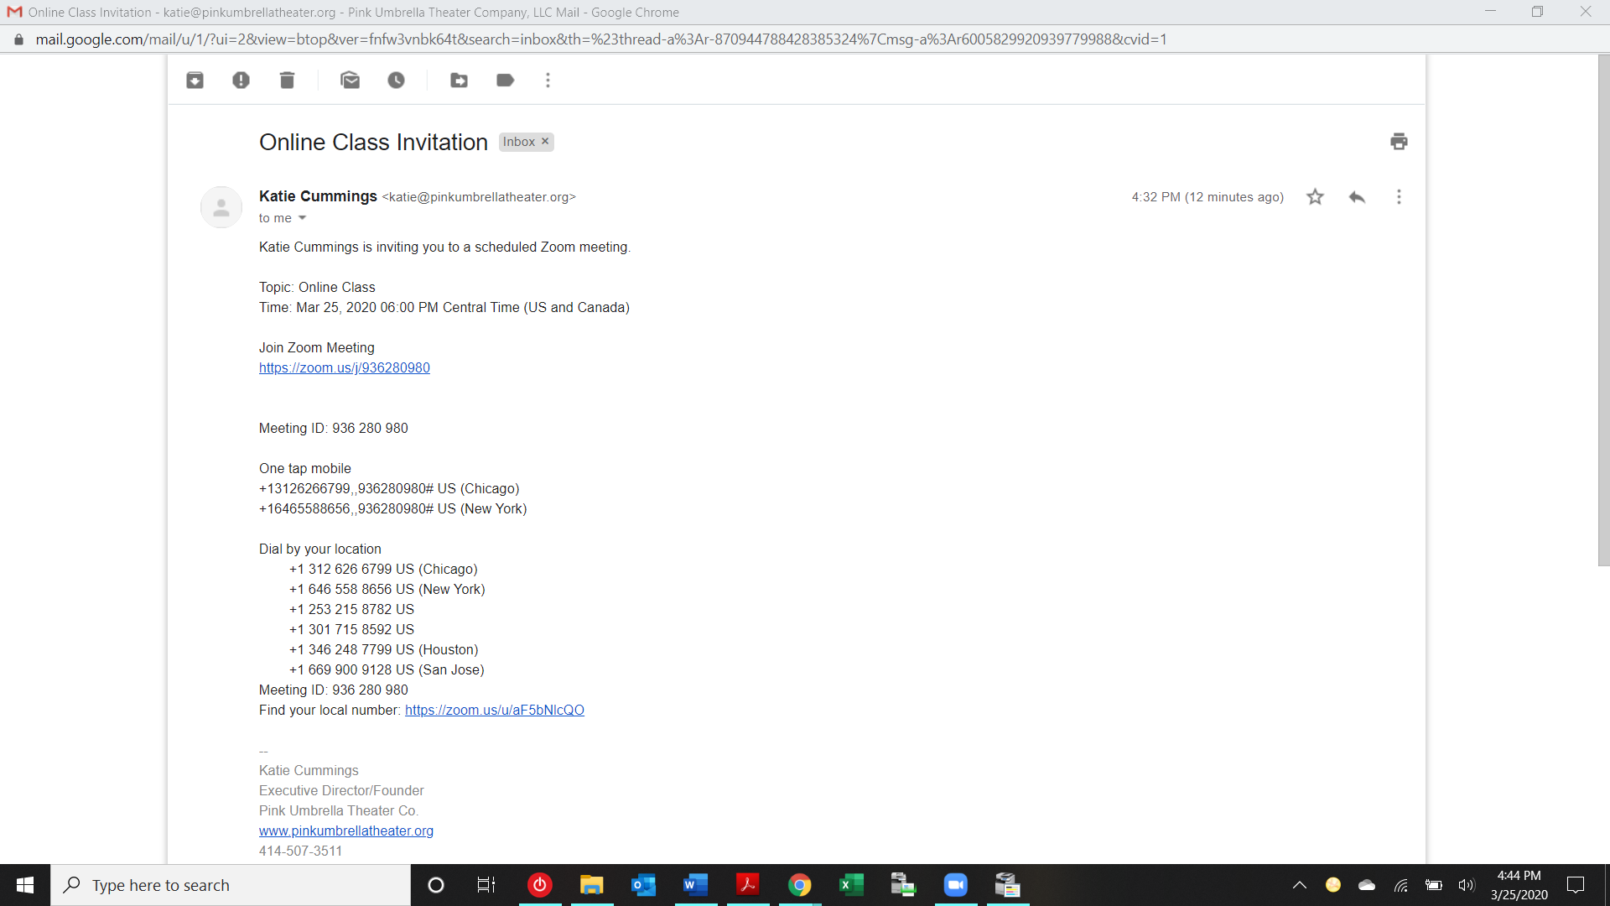

Then I can click the link that is in blue

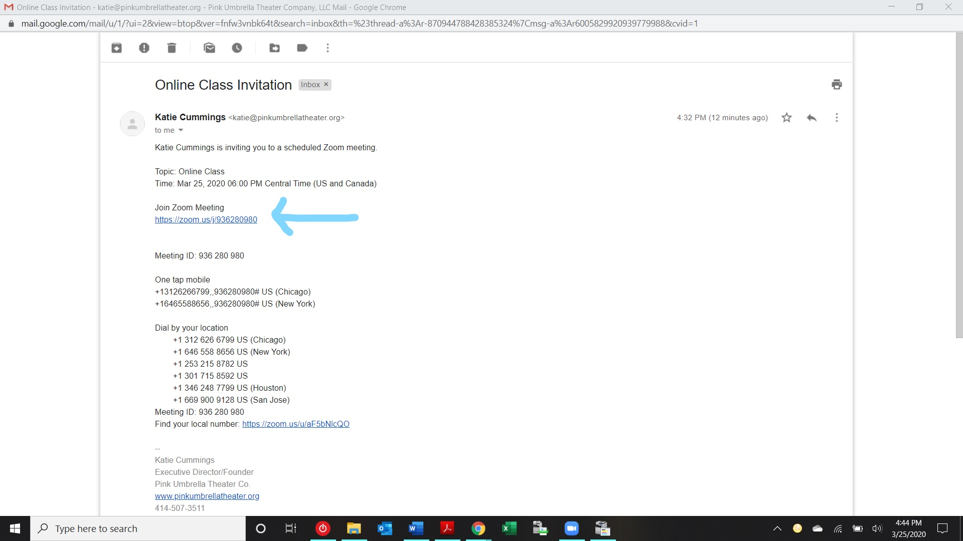

If I have never used Zoom before, I will have to download the application. This should start happening automatically when I visit the website.

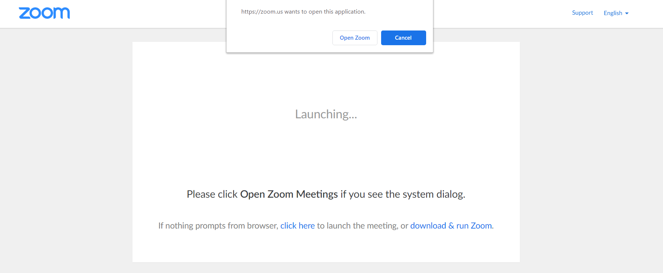

I can follow the instructions on the screen if I have trouble.
I will only need to do this step the first time I use Zoom on my device, not every time.

A new screen will pop up.
I can click the blue button that says “Join a Meeting”

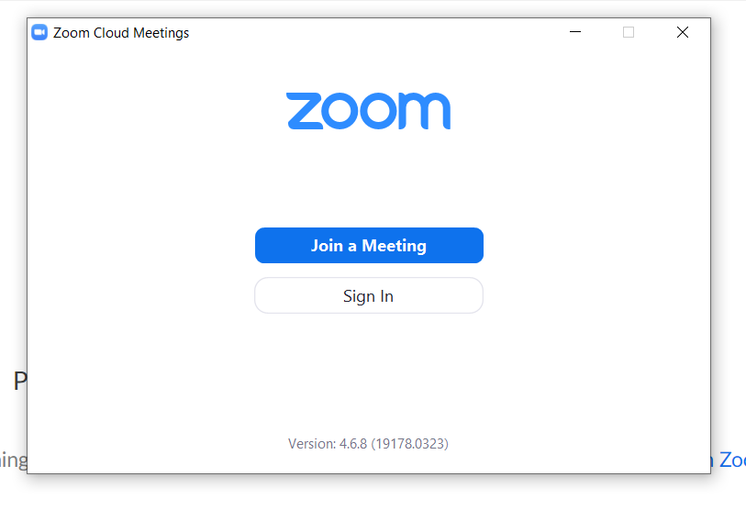
Another screen will pop up with a few different options.
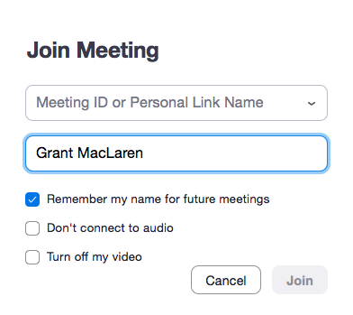
I can type in my name so it appears on the screen.
I can check the first checkbox so Zoom will remember my name.
I want people to be able to hear me and see me in class, so I should not check the bottom two boxes.
Then I can click the button that says “join”

I will then be in the online class with Pink Umbrella Theater!
Online class will follow a similar agenda as we do in person.

WELCOME
QUESTION OF THE DAY
WARM UP
THE WORK
REFLECTION

When class is over, I can hang up by clicking the red text at the bottom of my screen that says “Leave Meeting.”

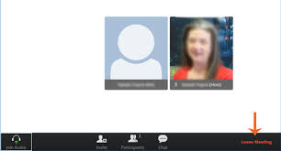

Then my online class is over! We will see each other next time!

